8-Puzzle Solver Documentation

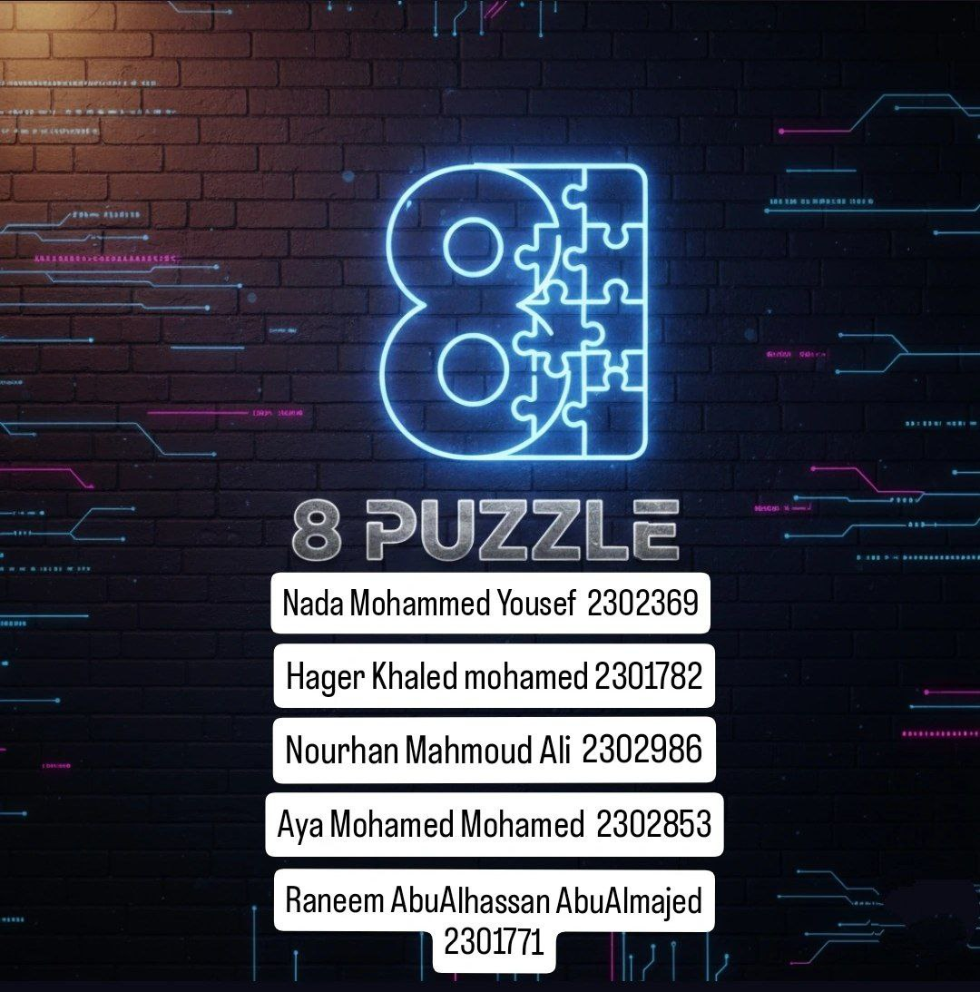

1️⃣ Project Idea
This project is an AI-powered 8-Puzzle Solver. The 8-Puzzle game consists of a 3×3 board with tiles numbered 1 to 8 and an empty space. The goal is to arrange the tiles in order from 1 to 8 with the empty space at the bottom-right corner.
Objective:
- Solve any given puzzle configuration automatically using AI algorithms.
- Provide a graphical interface for users to play or visualize the solution.

2️⃣ Algorithm Used
- Algorithm: A* Search Algorithm
- Description:
A* is a path-finding algorithm that finds the shortest sequence of moves to solve the puzzle. It uses a priority queue to explore board states based on the cost function:
- f(n) = g(n) + h(n)
Where:
  - g(n) is the cost to reach the current state.
  - h(n) is the heuristic estimation to reach the goal.
- Heuristics Implemented:
  - Manhattan Distance (default) – sum of distances of tiles from their goal positions.
  - Misplaced Tiles – counts tiles in the wrong position.
- Why A:* Guarantees the shortest solution path and efficiently handles small state spaces like the 8-Puzzle.

3️⃣ System Design
Simple Architecture:
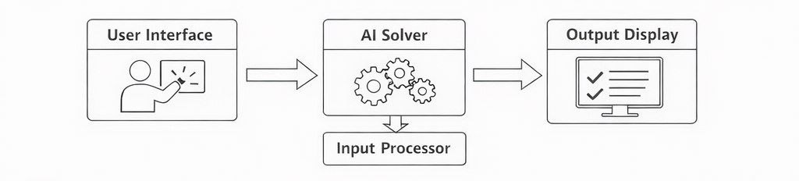
Explanation:
- User selects difficulty and enters initial puzzle configuration.
- AI Solver calculates the optimal solution using A*.
- Output Display shows solution steps and metrics (moves & time).

Components and Contributions
- main.py
  - Initializes the game and manages program execution.
  - Can run the game or trigger automated tests.
- astar.py
  - Implements the A* algorithm for solving the 8-Puzzle.
  - Integrates heuristic functions for optimal pathfinding.
- state.py
  - Represents the board state and provides helper functions.
  - Handles move generation, goal checking, and board manipulation.
- heuristic.py
  - Contains heuristic functions used by the A* algorithm.
  - Includes strategies like Manhattan Distance and Misplaced Tiles.
- test.py
  - Provides automated testing of the AI logic.
  - Verifies correctness and performance without requiring a graphical user interface (GUI).
- gamee.py
- Handles user interactions and displays the board state.
- Updates the game visually when tiles are moved.
- Connects with astar.py and state.py to apply AI solutions or player moves.

Note: The project uses a graphical user interface (GUI) to provide an interactive experience for the 8-Puzzle game. The GUI is a feature of the project as a whole and is not attributed to any individual.

4️⃣ How to Run the Project
Requirements:
- Python 3.x
- Libraries: tkinter (GUI) , time , heapq , numpy (if needed)
Steps:
- Open terminal and navigate to the project folder.
- Run the main script:
python main.py
- Select difficulty in the GUI window (Easy, Medium, Hard).
- Use arrow keys to move tiles manually or click Solve Automatically to see the AI solve it.
To run tests without GUI:
python test.py

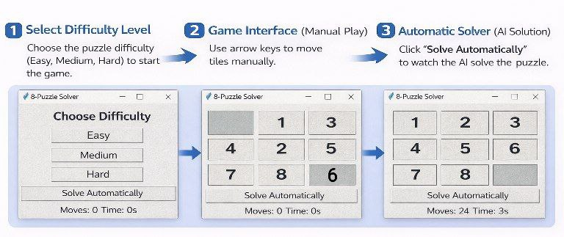

5️⃣ Sample Input / Output (Easy Level)
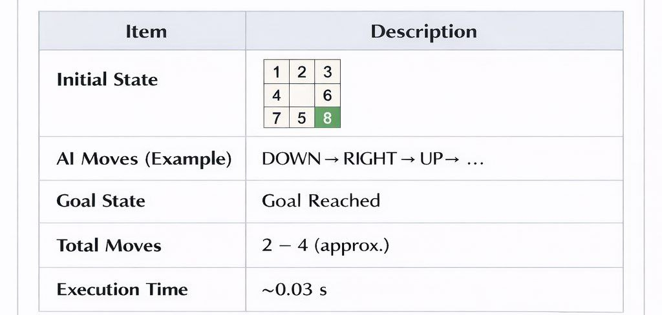

Note:
The number of moves and execution time may vary slightly depending on system performance and heuristic behavior.

6️⃣ Testing
The AI was tested on Easy, Medium, and Hard configurations using the A* search algorithm.
The following table shows sample results obtained during testing:
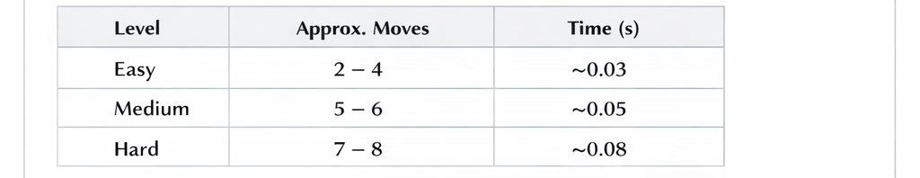
These results confirm that the A* algorithm efficiently finds the shortest solution path.
Actual execution time and number of moves may vary slightly depending on the system.

